ASSIGNMENT-4.3

PROMPT:

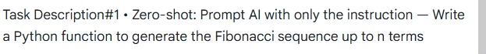

CODE:

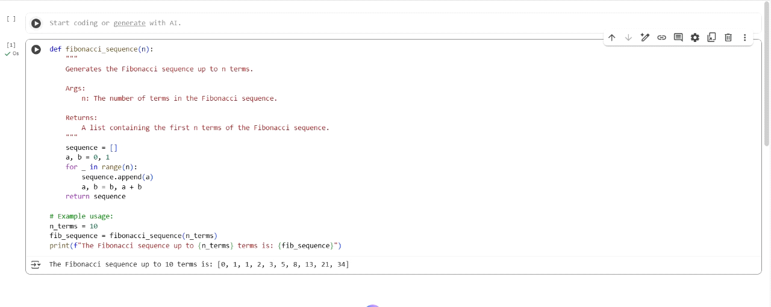

PROMPT:



CODE:

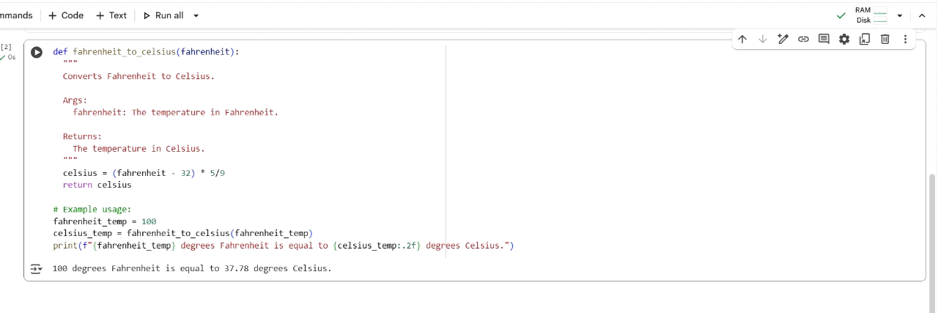

PROMPT:

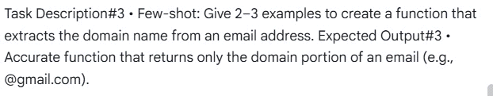

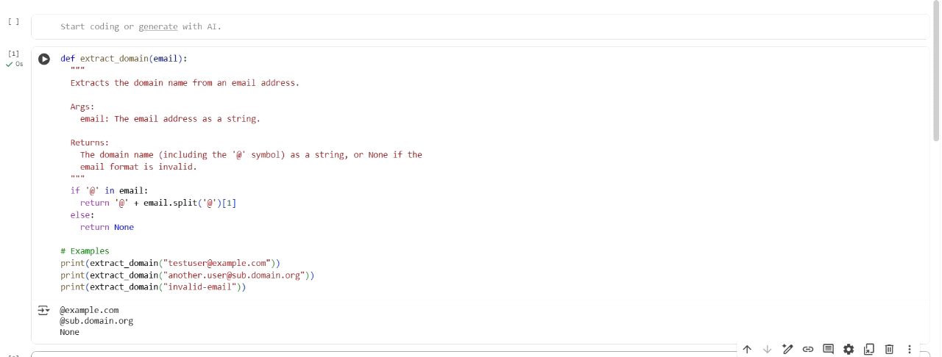

PROMPT:

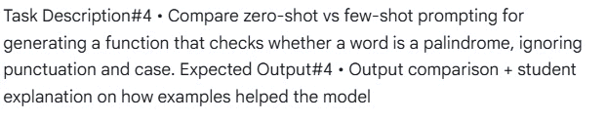

CODE:

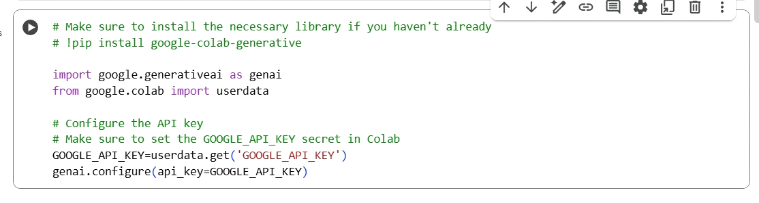

PROMPT:

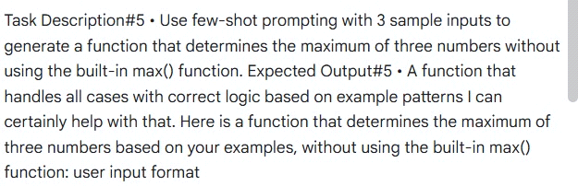

CODE:

